**Ideation Phase**

**Define the Problem Statements**

|  |  |
| --- | --- |
| Date | 27 October 2022 |
| Team Id | PNT2022TMID11716 |
| Project Name | Web Phishing Detection |
| Maximum Marks | 2 Marks |

Web Phishing Detection problem Statement:



Phishing attacks are becoming more and more sophisticated, and our algorithms are suffering to keep up with this level of sophistication. They have low detection rate and high false alarm especially when novel phishing approaches are use. The blacklist-based method is unable to keep up with the current phishing attacks as registering new domains has become easier. Moreover, comprehensive blacklist can ensure a perfect up-to-date database. Various other techniques such as page content inspection algorithms have been used to combat the false negatives but as each algorithm uses a different approach, their accuracy varies. Therefore, a combination of the two can increase the accuracy while implementing different error detection methods.

Problem Statement 1:



Problem Statement 2:



Problem Statement 3:



Problem Statement 4:

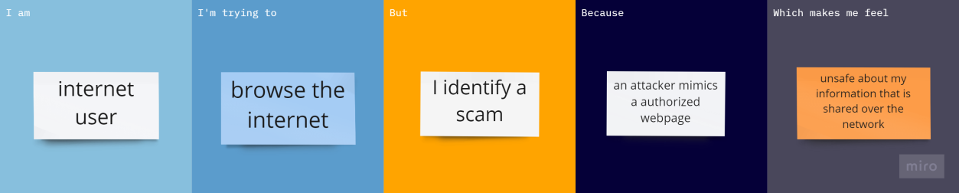

|  |  |  |  |  |  |
| --- | --- | --- | --- | --- | --- |
| **Problem**  **Statement (PS)** | **I am**  **(Customer)** | **I’m trying to** | **But** | **Because** | **Which makes me**  **feel** |
| PS-1 | Vendor | Use online transactions | I find  illegal  pages who indulge in bankruptcy | Of counterfeit websites who steal credentials | Unsafe about online transactions |
| PS-2 | Account holder in Bank | Use credit and withdraw money from bank account | I find  fraudulent webpages who steal account details | an attacker masquerades a reputable entity | doubtful about using those features |
| PS-3 | enterprise user | open mails in the cloud server | I detect malicious mails | they are not cryptographically signed | Emails are not verified and third party intrusions |
| PS-4 | internet user | browse the internet | I identify a scam | an attacker mimics a authorized webpage | unsafe about my information that is shared over the network |